# Chapter 5 - Foundations of Employee Motivation

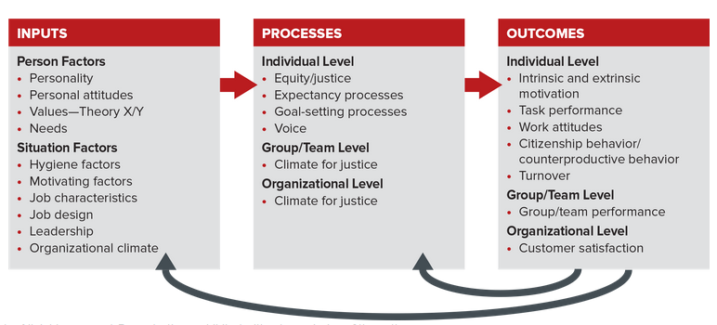

Should You Discuss Pay While at Work?

The answer depends on your role and position. Experts contend that the National Labor Relations Act prohibits companies from stopping the rank and file (employees paid by the hour) from discussing salary and benefits packages outside work time. “Outside work time” means on social media as well. T-Mobile was recently found guilt of violating national labor laws by prohibiting employees from talking with each other about wages. The rules are different, however, for managers and supervisors, who can legally be prevented from discussing their pay.

## 5.1 The What and Why of Motivation.

Motivation: What Is It?

How Does It Work?

The term motivation derives from the Latin word movere, meaning “to move.” In the present context, motivation describes the psychological processes “that underlie the direction, intensity, and persistence of behavior or thought.” “Direction pertains to what an individual is attending to at a given time, intensity represents the amount of effort being invested in the activity, and persistence represents for how long that activity is the focus of one’s attention.”

Extrinsic motivation results from the potential or actual receipt of external rewards. Extrinsic rewards such as recognition, money, or a promotion represent a payoff we receive from others for performing a particular task. For example, the Air Force is offering a bonus to drone pilots if they extend their commitment to remain in the military. These pilots can earn a $15,000 annual bonus by extending for either five or nine years, and they have the option to receive half the total bonus up front. The Air Force is doing this because the demand for drone pilots exceeds the supply.

Intrinsic motivation occurs when an individual is inspired by “the positive internal feelings that are generated by doing well, rather than being dependent on external factors (such as incentive pay or compliments from the boss) for the motivation to work effectively.” We create our own intrinsic motivation by giving ourselves intrinsic rewards such as positive emotions, satisfaction, and self-praise. Consider the intrinsic motivation of the 2015 winners of Dancing with the Stars Bindi Irwin and Derek Hough. The joy on their faces demonstrates the engagement and fun they are having while dancing.

The Two Fundamental Perspectives on Motivation: An Overview.

Researchers have proposed two general categories of motivation theories: content theories and process theories. Content theories identify internal factors such as needs and satisfaction that energize employee motivation. Process theories explain the process by which internal factors and situational factors influence employee motivation. It's important to understand both motivational perspectives because they offer different solutions for handling motivational problems. The following two sections discuss several theories for each theoretical perspective.

## 5.2 Content Theories of Motivation.

Most content theories of motivation are based on the idea that an employee’s needs influence his or her motivation. Content theorists ask, “What are the different needs that activate motivation’s direction, intensity, and persistence?” Needs are defined as physiological or psychological deficiencies that arouse behavior. They can be strong or weak and are influenced by environmental factors. This tells you that human needs vary over time and place.

Content theories include:

(1) McGregor’s Theory X and Theory Y.

(2) Maslow’s need hierarchy theory.

(3) Acquired needs theory.

(4) Self-determination theory.

(5) Herzberg’s motivator-hygiene theory.

McGregor’s Theory X and Theory Y.

Douglas McGregor outlined his theory in his book The Human Side of Enterprise. Drawing on his experience as a management consultant, McGregor formulated two sharply contrasting sets of assumptions about human nature. Theory X is a pessimistic view of employees: They dislike work, must be monitored, and can be motivated only with rewards and punishment (“carrots and sticks”). McGregor felt this was the typical perspective held by managers. To help them break with this negative tradition, McGregor formulated his own Theory Y. Theory Y is a modern and positive set of assumptions about people at work: They are self-engaged, committed, responsible, and creative.

Maslow’s Need Hierarchy Theory: Five Levels of Needs.

In 1943, psychologist Abraham Maslow published his now-famous need hierarchy theory of motivation. Although the theory was based on his clinical observation of a few neurotic individuals, it has subsequently been used to explain the entire spectrum of human behavior. The need hierarchy theory states that motivation is a function of five basic needs: (1) physiological, (2) safety, (3) love, (4) esteem, and (5) self-actualization. See Figure 5.2 for an explanation.

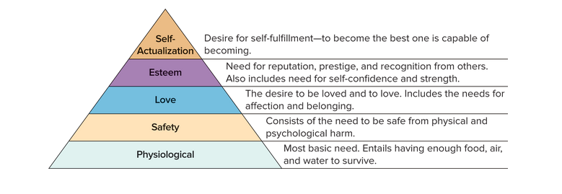

The Five Levels,

Maslow proposed that the five needs are met sequentially and relate to each other in a “prepotent” hierarchy (see Figure 5.2). Prepotent means the current most-pressing need will be met before the next need becomes the most powerful or potent. In other words, Maslow believed human needs generally emerge in a predictable stair-step fashion. Thus when physiological needs have been met, safety needs emerge, and so on up the need hierarchy, one step at a time. Once a need has been satisfied, it activates the next higher need in the hierarchy. This process continues until the need for self-actualization has been activated.

Using Maslow’s Theory to Motivate Employees,

This theory tells us that a “one style fits all” approach to motivation is unlikely to work. For example, studies show that different motivators are needed for employees working at small firms. George Athan, CEO of MindStorm Strategic Consulting, aptly noted, “People go to small companies to be part of something that will grow. They like the flexibility, too. The more they are involved in decision making, the more they feel it’s their mini-company.” A final lesson of Maslow’s theory is that satisfied needs lose their motivational potential. Therefore, managers are advised to motivate employees by devising programs or practices aimed at satisfying emerging or unmet needs.

Acquired Needs Theory: Achievement, Affiliation, and Power,

David McClelland, a well-known psychologist, began studying the relationship between needs and behavior in the late 1940s. He proposed the acquired needs theory, which states that three needs for achievement, affiliation, and power are the key drivers of employee behavior. McClelland used the term “acquired needs” because he believes we are not born with our needs; rather we learn or acquire them as we go about living our lives.

The Three Acquired Needs,

McClelland’s theory directs managers to drive employee motivation by appealing to three basic needs: (1) Need for achievement, the desire to excel, overcome obstacles, solve problems, and rival and surpass others. (2) Need for affiliation, the desire to maintain social relationships, be liked, and join groups. (3) Need for power, the desire to influence, coach, teach, or encourage others to achieve.

People vary in the extent to which they possess these needs, and often one need dominates the other two (see Figure 5.3).

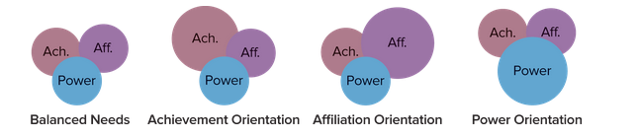

McClelland identified a positive and negative form of the power need. The positive side is called the need for institutional power. It manifests in the desire to organize people in the pursuit of organizational goals and help people obtain the feeling of competence. The negative face of power is called the need for personal power. People with this need want to control others, and they often manipulate people for their own gratification.

You can apply acquired needs theory by appealing to the preferences associated with each need when you (1) set goals, (2) provide feedback, (3) assign tasks, and (4) design the job. Let's consider how the theory applies to Cameron Mitchell.

Need for achievement. People motivated by the need for achievement, like Cameron Mitchell, prefer working on challenging, but not impossible, tasks or projects. They like situations in which good performance relies on effort and ability rather than luck, and they like to be rewarded for their efforts. High achievers also want to receive a fair and balanced amount of positive and negative feedback. This enables them to improve their performance.

Need for affiliation. People motivated by the need for affiliation like to work in teams and in organizational climates characterized as cooperative and collegial. You clearly see this theme at work in Cameron Mitchell’s restaurants.

Need for power. People with a high need for power like to be in charge. They enjoy coaching and helping others develop. Cameron Mitchell seems to exemplify this need.

Self-Determination Theory: Competence, Autonomy, and Relatedness,

Self-determination theory was developed by psychologists Edward Deci and Richard Ryan. In contrast to McClelland’s belief that needs are learned over time, this theory identifies innate needs that must be satisfied for us to flourish. Self-determination theory assumes that three innate needs influence our behavior and well-being the needs for competence, autonomy, and relatedness.

Self-Determination Theory Focuses on Intrinsic Motivation,

Self-determination theory focuses on the needs that drive intrinsic motivation. Intrinsic motivation is longer lasting and has a more positive impact on task performance than extrinsic motivation. The theory proposes that our needs for (1) competence, (2) autonomy, and (3) relatedness produce intrinsic motivation, which in turn enhances our task performance. Research supports this proposition.

The Three Innate Needs, an innate need is a need we are born with. The three innate needs are:

Competence “I need to feel efficacious.” This is the desire to feel qualified, knowledgeable, and capable to complete an act, task, or goal.

Autonomy “I need to feel independent to influence my environment.” This is the desire to have freedom and discretion in determining what you want to do and how you want to do it.

Relatedness “I want to be connected with others.” This is the desire to feel part of a group, to belong, and to be connected with others.

Using Self-Determination Theory to Motivate Employees,

Managers can apply self-determination theory by trying to create work environments that support and encourage the opportunity to experience competence, autonomy, and relatedness. Here are some specific suggestions:

Herzberg’s Motivator-Hygiene Theory: Two Ways to Improve Satisfaction,

Frederick Herzberg’s theory is based on a landmark study in which he interviewed 203 accountants and engineers. These interviews, meant to determine the factors responsible for job satisfaction and dissatisfaction, uncovered separate and distinct clusters of factors associated with each. This pattern led to the motivator-hygiene theory, which proposes that job satisfaction and dissatisfaction arise from two different sets of factors satisfaction comes from motivating factors and dissatisfaction from hygiene factors.

Hygiene factors What makes employees dissatisfied? Job dissatisfaction was associated primarily with factors in the work context or environment. Herzberg hypothesized that such hygiene factors including company policy and administration, technical supervision, salary, interpersonal relationships with supervisors, and working conditions cause a person to move from a state of no dissatisfaction to dissatisfaction. He did not believe their removal created an immediate impact on satisfaction or motivation (for that, see motivating factors following). At best, Herzberg proposed that individuals will experience the absence of job dissatisfaction when they have no grievances about hygiene factors.

Motivating factors What makes employees satisfied? Job satisfaction was more frequently associated with factors in the work content of the task being performed. Herzberg labeled these motivating factors or motivators because each was associated with strong effort and good performance. He hypothesized that such motivating factors, or motivators including achievement, recognition, characteristics of the work, responsibility, and advancement cause a person to move from a state of no satisfaction to satisfaction. Therefore, Herzberg’s theory predicts managers can motivate individuals by incorporating motivators into an individual’s job.

For Herzberg, the groups of hygiene and motivating factors did not interact. “The opposite of job satisfaction is not job dissatisfaction, but rather no job satisfaction; and similarly, the opposite of job dissatisfaction is not job satisfaction, but no dissatisfaction.” Herzberg conceptualizes dissatisfaction and satisfaction as two parallel continuums. The starting point is a null state in which both dissatisfaction and satisfaction are absent. Theoretically an organization member could have good supervision, pay, and working conditions (no dissatisfaction) but a tedious and unchallenging task with little chance of advancement (no satisfaction), as illustrated in Figure 5.4.

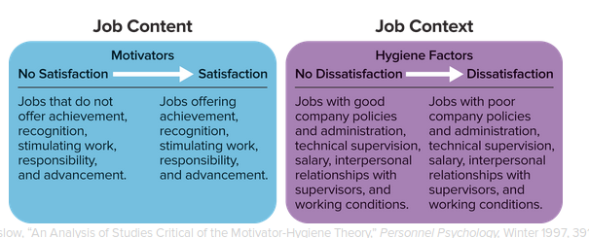

Using Herzberg’s Theory to Motivate Employees,

Research does not support the two-factor aspect of Herzberg’s theory, nor the proposition that hygiene factors are unrelated to job satisfaction. However, three practical applications of the theory help explain why it remains important in OB.

Hygiene first. There are practical reasons to eliminate dissatisfaction before trying to use motivators to increase motivation and performance. You will have a harder time motivating someone who is experiencing pay dissatisfaction or otherwise struggling with Herzberg’s hygiene factors.

Motivation next. Once you remove dissatisfaction, you can hardly go wrong by building motivators into someone’s job. This suggestion represents the core idea behind the technique of job design that is discussed in the final section of this chapter.

A few well-chosen words. Finally, don’t underestimate the power of verbal recognition to reinforce good performance. Savvy managers supplement Herzberg’s motivators with communication. Positive recognition can fuel intrinsic motivation, particularly for people who are engaged in their work.

Figure 5.5 illustrates the overlap among the need and satisfaction theories discussed in this section. As you can see, the acquired needs and self-determination theories do not include lower-level needs. Remember, higher-level need satisfaction is more likely to foster well-being and flourishing.

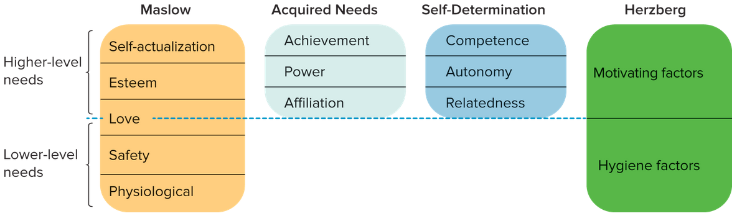

## 5.3 Process Theories of Motivation

Equity/Justice Theory: Am I Being Treated Fairly?

Defined generally, equity theory is a model of motivation that explains how people strive for fairness and justice in social exchanges or give-and-take relationships. According to this theory, people are motivated to maintain consistency between their beliefs and their behavior. Perceived inconsistencies create cognitive dissonance (or psychological discomfort), which in turn motivates corrective action. When we feel victimized by unfair social exchanges, the resulting cognitive dissonance prompts us to correct the situation. This can result in a change of attitude or behavior. Consider what happened when Michelle Fields, a former reporter for Breitbart News, a conservative news and opinion website and radio program, was covering a press conference for Donald Trump during the 2016 presidential campaign.

Psychologist J. Stacy Adams pioneered the use of equity theory in the workplace. Let us begin by discussing his ideas and their current application. We then discuss the extension of equity theory into justice theory and conclude by discussing how to motivate employees with both these tools.

The Elements of Equity Theory: Comparing My Outputs and Inputs with Those of Others

The key elements of equity theory are outputs, inputs, and a comparison of the ratio of outputs to inputs (see Figure 5.6).

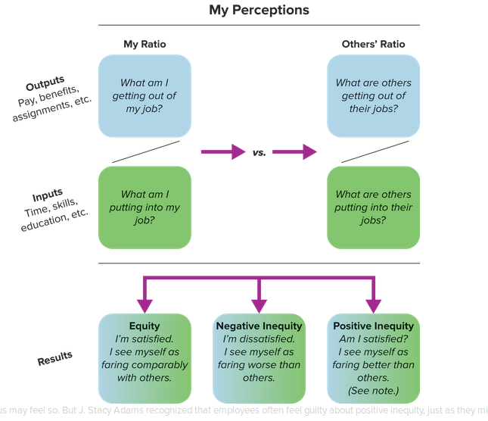

Outputs “What do I perceive that I’m getting out of my job?” Organizations provide a variety of outcomes for our work, including pay/bonuses, medical benefits, challenging assignments, job security, promotions, status symbols, recognition, and participation in important decisions. Outcomes vary widely, depending on the organization and our rank in it.

Inputs “What do I perceive that I’m putting into my job?” An employee’s inputs, for which he or she expects a just return, include education/training, skills, creativity, seniority, age, personality traits, effort expended, experience, and personal appearance.

Comparison “How does my ratio of outputs to inputs compare with those of relevant others?” Your feelings of equity come from your evaluation of whether you are receiving adequate rewards to compensate for your collective inputs. In practice people perform these evaluations by comparing the perceived fairness of their output-to-input ratio to that of relevant others (see Figure 5.6). They divide outputs by inputs, and the larger the ratio, the greater the expected benefit. This comparative process was found to generalize across personalities and countries.

The Outcomes of an Equity Comparison,

Figure 5.6 shows the three different equity relationships resulting from an equity comparison: equity, negative inequity, and positive inequity. Because equity is based on comparing ratios of outcomes to inputs, we will not necessarily perceive inequity just because someone else receives greater rewards. If the other person’s additional outcomes are due to his or her greater inputs, a sense of equity may still exist. However, if the comparison person enjoys greater outcomes for similar inputs, negative inequity will be perceived. On the other hand, a person will experience positive inequity when his or her outcome-to-input ratio is greater than that of a relevant comparison person.

The Elements of Justice Theory: Distributive, Procedural, and Interactional Justice,

Beginning in the later 1970s, researchers began to expand the role of equity theory in explaining employee attitudes and behavior. This led to a domain of research called organizational justice. Organizational justice reflects the extent to which people perceive they are treated fairly at work. This, in turn, led to the identification of three different components of organizational justice: distributive, procedural, and interactional.

Distributive justice reflects the perceived fairness of the way resources and rewards are distributed or allocated. Do you think fairness matters when it comes to the size of people’s offices? Robert W. Baird & Co., a financial services firm ranked as Fortune’s sixth-best place to work in 2016, did. The company decided to make everyone’s office the same size in its newly renovated headquarters.

Procedural justice is the perceived fairness of the process and procedures used to make allocation decisions.

Interactional justice describes the “quality of the interpersonal treatment people receive when procedures are implemented.” Interactional justice does not pertain to the outcomes or procedures associated with decision making. Instead it focuses on whether people believe they are treated fairly when decisions are being implemented.

The Outcomes Associated with Justice,

Doesn’t it make sense that your perceptions of justice are related to outcomes in the Organizing Framework? Of course! This realization has generated much research into organizational justice over the last 25 years. We created Figure 5.7 to summarize these research findings. The figure shows the strength of relationships between nine individual-level outcomes and the three components of organizational justice. By and large, distributive and procedural justice have consistently stronger relationships with outcomes. This suggests that managers would be better off paying attention to these two forms of justice. In contrast, interactional justice is not a leading indicator in any instance.

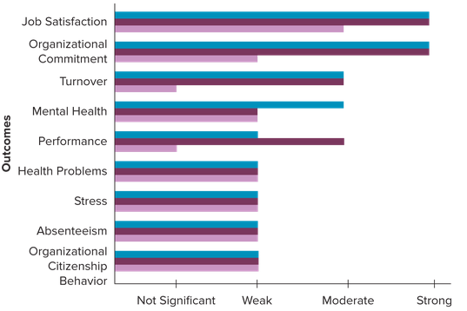

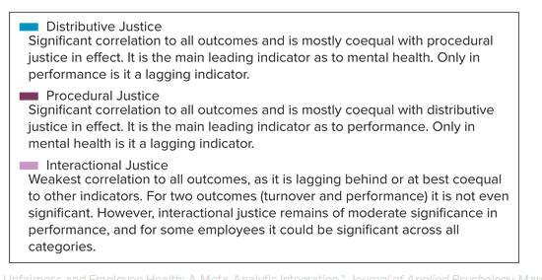

Using Equity and Justice Theories to Motivate Employees,

Figure 5.7 notwithstanding, managers can’t go wrong by paying attention to employees’ perceptions of equity and justice at work. Here are five practical lessons to help you apply equity and justice theories.

Employee perceptions count. No matter how fair management thinks the organization’s policies, procedures, and reward system are, each employee’s perception of the equity of those factors is what counts. For example, females were found to be more sensitive to injustice when it came to procedural and distributive issues regarding rewards. Further, justice perceptions can change over time. This implies that it is important for managers to regularly assess employees’ justice beliefs. Companies tend to do this by using annual employee work attitude surveys.

Employees want a voice in decisions that affect them. Employees’ perceptions of justice are enhanced when they have a voice in the decision-making process. Voice is the discretionary or formal expression of ideas, opinions, suggestions, or alternative approaches directed to a specific target inside or outside of the organization with the intent to change an objectionable state of affairs and to improve the current functioning of the organization.” Managers are encouraged to seek employee input on organizational issues that are important to employees, even though many employees are reluctant to use their “voice.” Mission Produce Inc., a large producer of avocados, took this recommendation to heart. According to HR chief Tracy Malmos, the company “implemented a pay structure in response to young employees' requests to 'take the mystery out of compensation.'” Managers can overcome these roadblocks to gaining employee input by creating a voice climate. A voice climate is one in which employees are encouraged to freely express their opinions and feelings.

Employees should have an appeals process. Employees should be given the opportunity to appeal decisions that affect their welfare. This opportunity fosters perceptions of distributive and procedural justice.

Leader behavior matters. Employees’ perceptions of justice are strongly influenced by their managers’ leadership behavior and the justice-related implications of their decisions, actions, and public communications. For example, employees at Honeywell felt better about being asked to take furloughs in which they go on unpaid leave but remain employed when they learned that David Cote, the company’s chair and CEO, did not take his $4 million bonus during the time employees were furloughed.

A climate for justice makes a difference. Team performance was found to be higher in companies that possessed a climate for justice. Do you think it’s OK for customers to yell at retail or service employees or treat them rudely? We don’t! A climate for justice incorporates relationships between employees and customers. Employees are more likely to provide poor customer service when managers allow customers to treat employees rudely or disrespectfully.

Expectancy Theory: Does My Effort Lead to Desired Outcomes?

Expectancy theory holds that people are motivated to behave in ways that produce desired combinations of expected outcomes. Generally, expectancy theory can predict behavior in any situation in which a choice between two or more alternatives must be made. For instance, it can predict whether we should quit or stay at a job, exert substantial or minimal effort at a task, and major in management, computer science, accounting, marketing, psychology, or communication.

The Elements of Vroom’s Expectancy Theory: Expectancy, Instrumentality, and Valence,

Motivation, according to Vroom, boils down to deciding how much effort to exert in a specific task situation. This choice is based on a two-stage sequence of expectations moving from effort to performance and then from performance to outcome. Figure 5.8 shows the major components of this theory.

Figure 5.8 Major elements of expectancy theory,

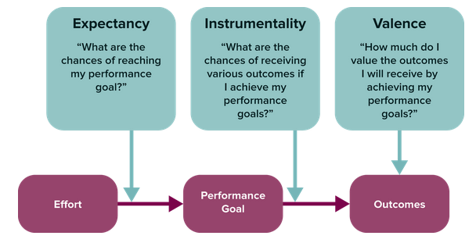

Let us consider the three key elements of Vroom’s theory.

Expectancy “Can I achieve my desired level of performance? An expectancy represents an individual’s belief that a particular degree of effort will be followed by a particular level of performance. Expectancies take the form of subjective probabilities. As you may recall from a course in statistics, probabilities range from zero to one. An expectancy of zero indicates that effort has no anticipated impact on performance, while an expectancy of one suggests performance is totally dependent on effort.

EXAMPLE Suppose you do not know how to use Excel. No matter how much effort you exert, your perceived probability of creating complex spreadsheets that compute correlations will be zero. If you decide to take an Excel training course and practice using the program a couple of hours a day for a few weeks (high effort), the probability that you will be able to create spreadsheets that compute correlations will rise close to one.

Research reveals that employees’ expectancies are affected by a host of factors. Some of the more important ones include self-efficacy, time pressures, task difficulty, ability and knowledge, resources, support from peers, leader behavior, and organizational climate.

Instrumentality “What intrinsic and extrinsic rewards will I receive if I achieve my desired level of performance?” Instrumentality is the perceived relationship between performance and outcomes. It reflects a person’s belief that a particular outcome is contingent on accomplishing a specific level of performance. Passing exams, for instance, is instrumental in graduating from college, or put another way, graduation is contingent on passing exams. Twitter decided to make bonuses instrumental in employees’ staying around. That’s right! Because too many employees were leaving, some were offered bonuses ranging from $50,000 to $200,000 just for remaining at the company for six to 12 months. The Problem-Solving Application box illustrates how various boards of directors are reducing the instrumentality between CEO pay and corporate performance. Do you think this is a good idea?

Valence “How much do I value the rewards I receive?” Valence describes the positive or negative value people place on outcomes. Valence mirrors our personal preferences. For example, most employees have a positive valence for receiving additional money or recognition. In contrast, being laid off or being ridiculed for making a suggestion would likely be negative valence for most individuals. In Vroom’s expectancy model, outcomes are consequences that are contingent on performance, such as pay, promotions, recognition, or celebratory events. For example, Aflac hosted a six-day appreciation week for employees that included theme park visits, movie screenings, and daily gifts. Would you value these rewards? Your answer will depend on your individual needs.

According to expectancy theory, your motivation will be high when all three elements in the model are high. If any element is near zero, your motivation will be low. Whether you apply this theory to yourself or managers apply it to their employees, the point is to simultaneously consider the status of all three elements.

Using Expectancy Theory to Motivate Employees,

Goal-Setting Theory: How Can I Harness the Power of Goal Setting?

Regardless of the nature of their specific achievements, successful people tend to have one thing in common: Their lives are goal-oriented. This is as true for politicians seeking votes as it is for world-class athletes like Michael Phelps. Research also supports this conclusion. The results of more than 1,000 studies from a wide range of countries clearly show that goal setting helps individuals, teams, and organizations to achieve success.

Edwin Locke and Gary Latham’s Theory of Goal Setting,

Goals that are specific and difficult lead to higher performance than general goals like “Do your best” or “Improve performance.” This is why it is essential to set specific, challenging goals. Goal specificity means whether a goal has been quantified. For example, a goal of increasing the score on your next OB test by 10 percent is more specific than the goal of trying to improve your grade on the next test.

Certain conditions are necessary for goal setting to work. People must have the ability and resources needed to achieve the goal, and they need to be committed to the goal. If these conditions are not met, goal setting does not lead to higher performance. Be sure these conditions are in place as you pursue your goals.

Performance feedback and participation in deciding how to achieve goals are necessary but not sufficient for goal setting to work. Feedback and participation enhance performance only when they lead employees to set and commit to a specific, difficult goal. Take Jim’s Formal Wear, a tuxedo wholesaler in Illinois. “Once a week, employees meet with their teams to discuss their efforts and what changes should be made the next week. Employees frequently suggest ways to improve efficiency or save money, such as reusing shipping boxes and hangers.” Goals lead to higher performance when you use feedback and participation to stay focused and committed to a specific goal.

Goal achievement leads to job satisfaction, which in turn motivates employees to set and commit to even higher levels of performance. Goal setting puts in motion a positive cycle of upward performance.

What Are the Mechanisms Behind the Power of Goal Setting?

Edwin Locke and Gary Latham, the same OB scholars who developed the motivational theory of goal setting just discussed, also identified the underlying mechanisms that explain how goals affect performance. There are four.

Goals direct attention. Goals direct our attention and effort toward goal-relevant activities and away from goal-irrelevant activities. If, for example, you have a term project due in a few days, your thoughts and actions tend to revolve around completing that project. In reality, however, we often work on multiple goals at once. Prioritize your goals so you can effectively allocate your efforts over time. For example, NuStar Energy, one of the largest asphalt refiners and operators of petroleum pipelines and product terminals in the United States, has decided to give safety greater priority than profits in its goals. This prioritization paid off when the company celebrated three years of zero time off due to injuries, and corporate profits are doing just fine.

Goals regulate effort. Goals have an energizing function in that they motivate us to act. As you might expect, harder goals foster greater effort than easy ones. Deadlines also factor into the motivational equation. We expend greater effort on projects and tasks when time is running out. For example, an instructor’s deadline for turning in your term project would prompt you to complete it instead of going out with friends, watching television, or studying for another course.

Goals increase persistence. Within the context of goal setting, persistence represents the effort expended on a task over an extended period of time. It takes effort to run 100 meters; it takes persistence to run a 26-mile marathon. One of your textbook authors Angelo Kinicki knows this because he ran a marathon. What an experience! His goal was to finish in 3 hours 30 minutes. A difficult goal like this served as a reminder to keep training hard over a three-month period. Whenever he wanted to stop training or run slow sprints, his desire to achieve the goal motivated him. Although he missed his goal by 11 minutes, it still is one of his proudest accomplishments. This type of persistence happens when the goal is personally important.

Goals foster the development and application of task strategies and action plans. Goals prompt us to figure out how we can accomplish them. This begins a cognitive process in which we develop a plan outlining the steps, tasks, or activities we must undertake. For example, teams of employees at Tornier, a medical device manufacturer in Amsterdam, meet every 45, 60, or 90 days to create action plans for completing their goals. Implementation of the plans can take between six and 18 months depending on the complexity of the goal. Setting and using action plans also reduces procrastination. If this is sometimes a problem for you, break your goals into smaller and more specific sub goals. That will get you going.

## 5.4 Motivating Employees through Job Design,

These quotations reflect the different outcomes that can result from job design. Job design, also referred to as job redesign or work design, refers to any set of activities that alter jobs to improve the quality of employee experience and level of productivity. As you can see from this definition, job design focuses on motivating employees by considering the situation factors within the Organizing Framework.

Figure 5.9 summarizes the approaches to job design that have developed over time.

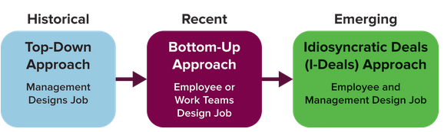

Top-Down Approaches Management Designs Your Job,

In top-down approaches, management creates efficient and meaningful combinations of work tasks for employees. If it is done correctly, in theory, employees will display higher performance, job satisfaction, and engagement, and lower absenteeism and turnover. The five principal top-down approaches are scientific management, job enlargement, job rotation, job enrichment, and the job characteristics model.

Scientific Management,

Scientific management draws from research in industrial engineering and is most heavily influenced by the work of Frederick Taylor (1856–1915). Taylor, a mechanical engineer, developed the principles of scientific management based on research and experimentation to determine the most efficient way to perform jobs. Scientific management is “that kind of management which conducts a business or affairs by standards established by facts or truths gained through systematic observation, experiment, or reasoning.”

Designing jobs according to the principles of scientific management has both positive and negative consequences. Positively, employee efficiency and productivity are increased. On the other hand, research reveals that simplified, repetitive jobs also lead to job dissatisfaction, poor mental health, higher levels of stress, and a low sense of accomplishment and personal growth. Recognition of these negative consequences paved the way for the next four top-down approaches.

Job Enlargement,

Companies first used job enlargement in the late 1940s in response to complaints about tedious and overspecialized jobs created from the principles of scientific management. Job enlargement puts more variety into a worker’s job by combining specialized tasks of comparable difficulty. Some call this strategy horizontally loading the job. Researchers recommend using job enlargement as part of a broader approach that uses multiple motivational methods, because by itself job enlargement does not have a significant and lasting positive effect on job performance.

Job Rotation,

Like job enlargement, job rotation gives employees greater variety in their work. Job rotation calls for moving employees from one specialized job to another. Rather than performing only one job, workers are trained and given the opportunity to perform two or more separate jobs on a rotating basis. Proposed benefits of job rotation include the following:79

Increased engagement and motivation because employees have a broader perspective on the organization.

Increased worker flexibility and easier scheduling because employees are cross-trained to perform different jobs.

Increased employee knowledge and abilities, which improves employees’ promotability and builds a pipeline of internal talent.

Job Enrichment,

Job enrichment is the practical application of Frederick Herzberg’s motivator-hygiene theory of job satisfaction, discussed earlier in this chapter. Specifically, job enrichment modifies a job such that an employee has the opportunity to experience achievement, recognition, stimulating work, responsibility, and advancement. These characteristics are incorporated into a job through vertical loading. Rather than giving employees additional tasks of similar difficulty (horizontal loading), vertical loading gives them more autonomy and responsibility. Intuit, for example, encourages employees “to spend 10 percent of their working time on projects and ideas of their own, even if they are not related to their assignments,” according to Fortune. The company finds that this practice has led to the creation of several successful new products.

The Job Characteristics Model,

Two OB researchers, J. Richard Hackman and Greg Oldham, played a central role in developing the job characteristics approach. They proposed that intrinsic motivation was determined by three psychological states. In turn, these psychological states were fostered by the presence of five core job characteristics (see Figure 5.10).

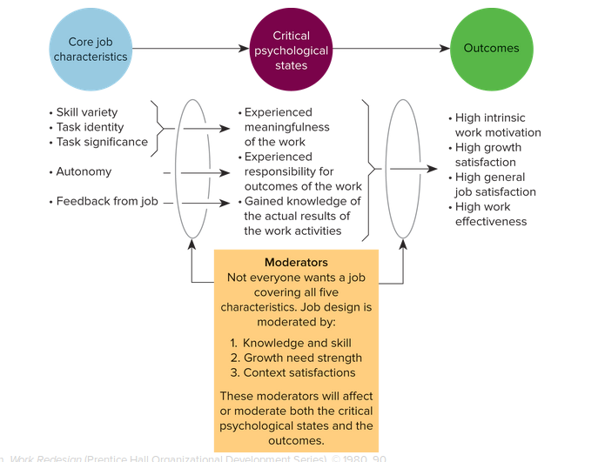

The goal of the job characteristics model is to promote high intrinsic motivation by designing jobs that possess the five core job characteristics. The five characteristics are as follows:

Skill variety. The extent to which the job requires an individual to perform a variety of tasks that require him or her to use different skills and abilities.

Task identity. The extent to which the job requires an individual to perform a whole or completely identifiable piece of work. Task identity is high when a person works on a product or project from beginning to end and sees a tangible result.

Task significance. The extent to which the job affects the lives of other people within or outside the organization.

Autonomy. The extent to which the job enables an individual to experience freedom, independence, and discretion in both scheduling and determining the procedures used in completing the job.

Feedback. The extent to which an individual receives direct and clear information about how effectively he or she is performing the job.

Moderators. A moderator is a variable that changes the relationship between two other variables. Hackman and Oldham proposed that there are moderators that affect the success of job design, and they are shown in the moderator box of Figure 5.10.

Bottom-Up Approaches You Design Your Own Job

As its name suggests, bottom-up job design is driven by employees rather than managers; it is also referred to as job crafting. Job crafting represents employees’ attempts to proactively shape their work characteristics. The goal of job crafting is to help employees experience a sense of meaning in their jobs. This is more important than you might think. A recent survey of 20,000 employees revealed that only 36 percent felt they had meaningful work.

Forms of Job Crafting,

Employees are viewed as “job crafters” according to the bottom-up model because they are expected to define and create their own job boundaries. Table 5.2 illustrates three forms of job crafting. The first changes the job’s task boundaries. You can do this by taking on more or fewer tasks or by altering their scope or nature. The second form changes the relational nature of the job. Specifically, you can alter the quantity or quality of interactions you have with others at work, or you can establish new relationships. The third method is cognitive crafting. In this strategy you perceive or think differently about the existing tasks and relationships associated with your job.

The right-hand column in Table 5.2 outlines the potential impact of job crafting on employee motivation and performance. You can see that job crafting is expected to change the way employees perceive their jobs. It should also result in more positive attitudes about the job, which is expected to increase employee motivation, engagement, and performance. Preliminary research supports this proposition.

Idiosyncratic Deals (I-Deals) You Negotiate the Design of Your Job

The last approach to job design, idiosyncratic deals, represents a middle ground between top-down and bottom-up methods and attempts to overcome their limitations. For example, top-down approaches are constrained by the fact that managers cannot always create changes in task characteristics that are optimal for everyone. Similarly, job crafting is limited by the amount of latitude people have to change their own jobs. Idiosyncratic deals (i-deals) represent “employment terms individuals negotiate for themselves, taking myriad forms from flexible schedules to career development.” Although “star performers” have long negotiated special employment contracts or deals, demographic trends and the changing nature of work have created increased opportunities for more employees to negotiate i-deals.

I-deals tend to affect task and work responsibilities, schedule flexibility, location flexibility, and compensation. The goal of such deals is to increase employee intrinsic motivation and productivity by allowing employees the flexibility to negotiate employment relationships that meet their own specific needs and values. RSM promotes and encourages the creation of i-deals among its 8,000 employees. The focus of its program is to create innovative and flexible ways of working.